IT210 Business Applications with C++

Programmer: Vijay Kalburgi

Volume calculator

Input/Output screenshots

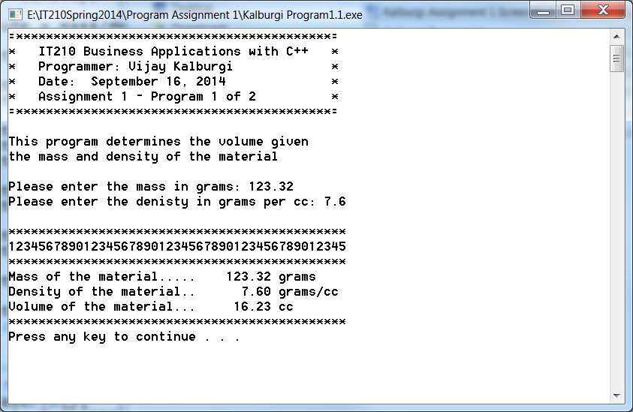

IT210 Business Applications with C++

Programmer: Vijay Kalburgi

Credit card interest calculator

Input/Output screenshots

